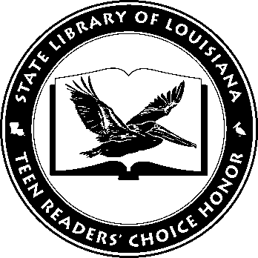

Louisiana’s Teen Readers’ Choice
Ballot 2016
Select only one title.

The 5th Wave. Rick Yancey

Eleanor & Park. Rainbow Rowell

Fangirl. Rainbow Rowell

The Living. Matt de la Peña

The Naturals. Jennifer Lynn Barnes

Orleans. Sherri Smith

Reclaimed. Sarah Guillory

Steelheart. Brandon Sanderson

War Brothers. Sharon McKay, illus. Daniel Lafrance

Winger. Andrew Smith, illus. Sam Bosma

The Louisiana Young Readers’ Choice Award is a reading enrichment program of the Louisiana Center for the Book in the State Library of Louisiana with additional support from the following:
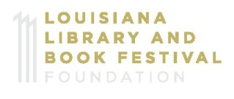

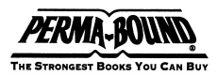

Louisiana’s Teen Readers’ Choice
Ballot 2016
Select only one title.

The 5th Wave. Rick Yancey

Eleanor & Park. Rainbow Rowell

Fangirl. Rainbow Rowell

The Living. Matt de la Peña

The Naturals. Jennifer Lynn Barnes

Orleans. Sherri Smith

Reclaimed. Sarah Guillory

Steelheart. Brandon Sanderson

War Brothers. Sharon McKay, illus. Daniel Lafrance

Winger. Andrew Smith, illus. Sam Bosma

The Louisiana Young Readers’ Choice Award is a reading enrichment program of the Louisiana Center for the Book in the State Library of Louisiana with additional support from the following:
