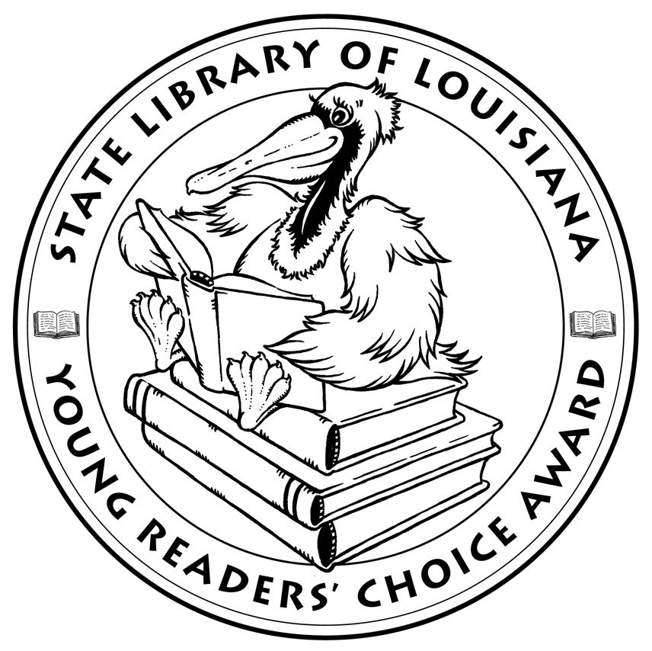

Louisiana’s Young Readers’ Choice
Ballot 2012 Grades 9-12

Beautiful Creatures. Kami Garcia and Margaret Stohl.

Hate List. Jennifer Brown.

If I Grow Up. Todd Strasser.

If I Stay: A Novel. Gayle Forman.

Iron Heart. Brian Boyle.

Mare’s War. Tanita S. Davis.

Ruined. Paula Morris.

Shiver. Maggie Stiefvater.

The Maze Runner. James Dashner.

Winter Girls. Laurie Halse Anderson.

State Library of Louisiana
Department of Culture, Recreation and Tourism

Louisiana’s Young Readers’ Choice
Ballot 2012 Grades 9-12

Beautiful Creatures. Kami Garcia and Margaret Stohl.

Hate List. Jennifer Brown.

If I Grow Up. Todd Strasser.

If I Stay: A Novel. Gayle Forman.

Iron Heart. Brian Boyle.

Mare’s War. Tanita S. Davis.

Ruined. Paula Morris.

Shiver. Maggie Stiefvater.

The Maze Runner. James Dashner..

Winter Girls. Laurie Halse Anderson.

State Library of Louisiana
Department of Culture, Recreation and Tourism

